Horde  
Game Art Bible

AIE’s The Walking Devs

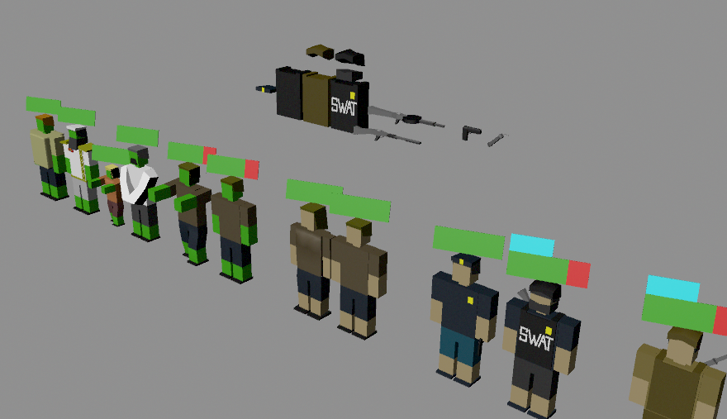Written by Brandon Nicholas & Rory McCaul  
30/3/2016

Table of Contents

Table of Contents 2/3

1.0 Art Style 4

1.1 Who lives in the environment 4

1.2 Time Period 5

1.3 Climate 5

1.4 Methods of construction 6

1.5 Technologies in use for hint of advancements 6

1.6 Character proportions 6

1.7 Architectural proportions 6

1.8 Environment scale 7

2.0 Character Art 7

2.1 Style and construction 7

2.2 Costume/drapery 7

2.3 Color palette 7

2.4 Height scale comparison 8

2.5 Posing 8

2.6 Expressions 9

3.0 L.o.d. 9

3.1 Architectural details 9

3.2 Character details 9

3.3 What and what not to detail 10

3.4 Differences of detail in narrative, gameplay and UI 10

4.0 Camera 10

4.1 Gameplay angle and character position 10

4.2 Narrative/story sequences 10

4.3 Camera FX 11

5.0 Colour palette 11

5.1 Environments with distinctly different palette choices 11

5.2 Color swatches 11

6.0 Atmosphere/environment 12

6.1 Openness 12

6.2 Scale 12

7.0 User Interface 13

7.1 Interface design technique 13

7.2 UX (User Experience) 13

7.3 Menu items and HUD 13

7.4 Animations 14

8.0 Technical Guidelines 14

8.1 Tools to use 14

8.2 Limitations 14

8.3 Resource collection and structuring 14

8.4 Naming conventions 14

8.5 Exporting 14

9.0 References 15

9.1 Games 15

9.2 Videos and movies 16

9.3 Comics 16

9.4 Photographs 17

9.5 Illustrations 18

1. **Art Style**

**1.1** **Who lives in the environment**

**Humans:**

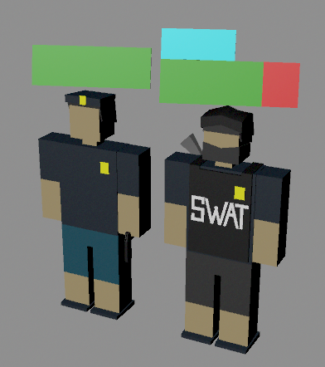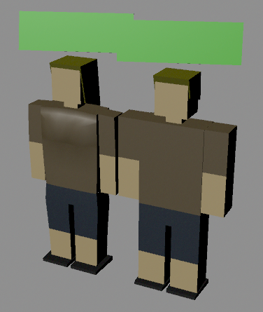Civilians Police Officers/SWAT Soldiers

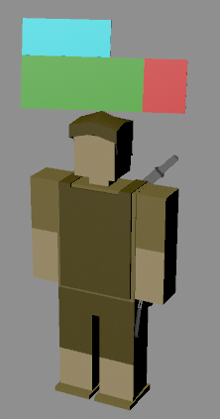

Survivors Miscellaneous items

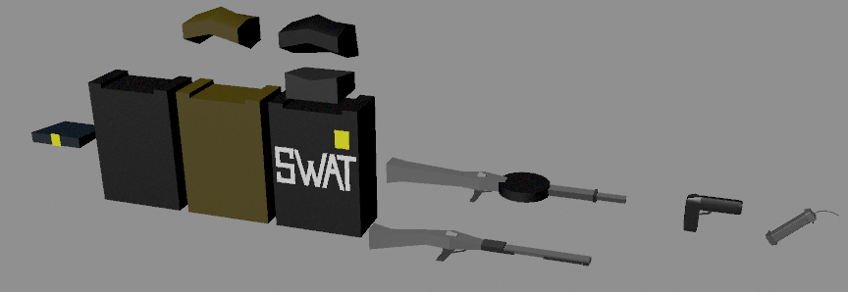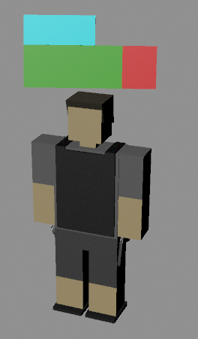

Straitjacket Dictator Actor Little Girl

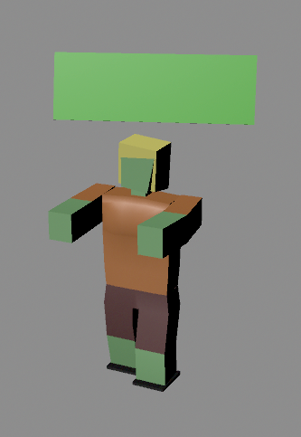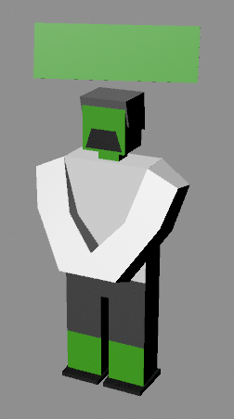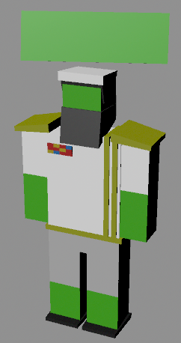

**Infected:**

Zombies

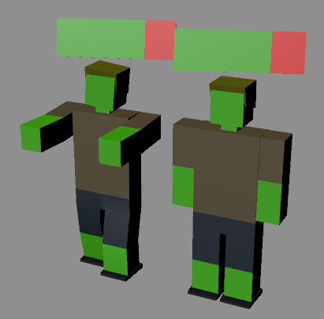

Obese Zombie Ice Cream Truck Driver

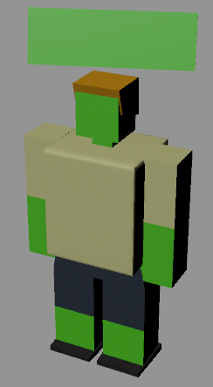

To be modelled

**1.2 Time Period**

Horde is set in a present time city environment.

**1.3 Climate**

Climate throughout the game will usually remain clear aside from possible occasions such as dramatic points in the story. This is mainly to maintain low running costs for the platform.

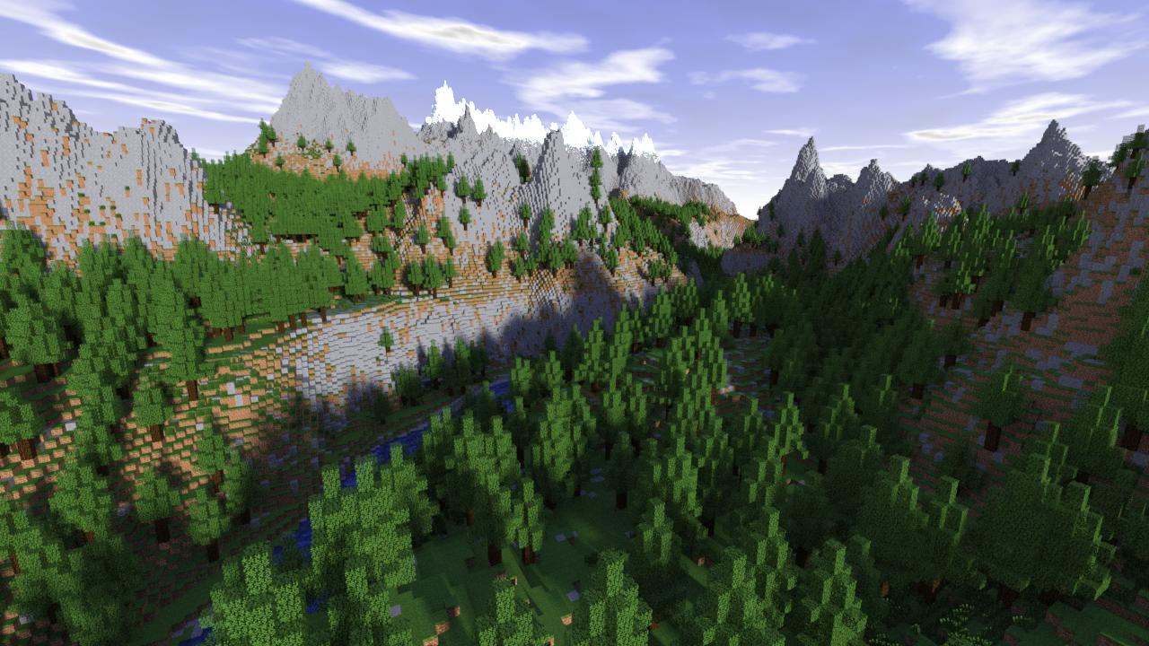Clear Weather: (Normal Weather)

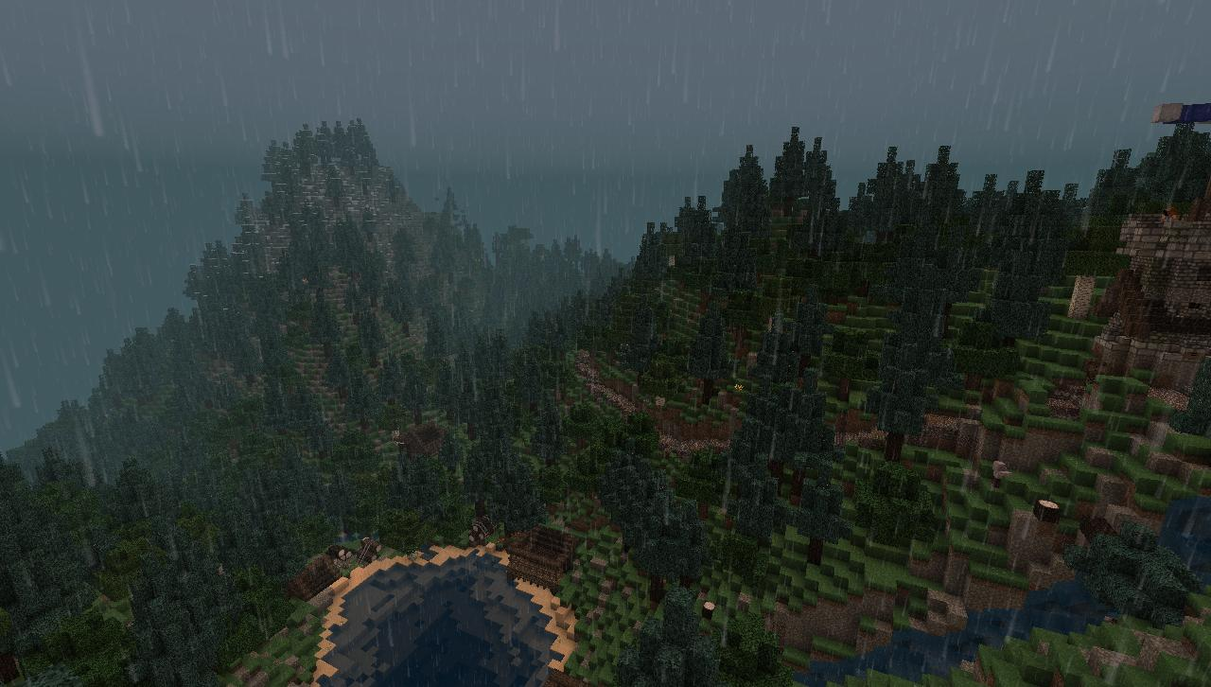Stormy Weather: (Dramatic use in story moments)

**1.4 Methods of construction**

Level design:

Level design will mainly revolve around modular pieces to allow for ease of building individual levels quickly. Levels will be pre built and not randomly generated as to allow for designers to plan story elements around potential paths.  
**Currently working on ways of loading the level to reduce system stress**  
(Possibly only loading in what the player sees)

**1.5 Technologies in use for hint of advancements**

As the game is set within a quarantine zone with individual territories as levels the player is progressing to take complete control and break free. Players will eventually only be able to find more humans to eat outside of their infected zones, drawing them toward populated zones and continuing to progress them through the game.

**1.6 Character proportions**

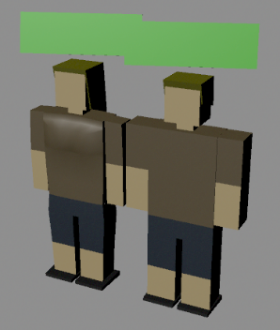Characters should represent similar scales to real life people, only characters such as abominations should have different scales as their bodies have mutated and changed shape.

**1.7 Architectural proportions**

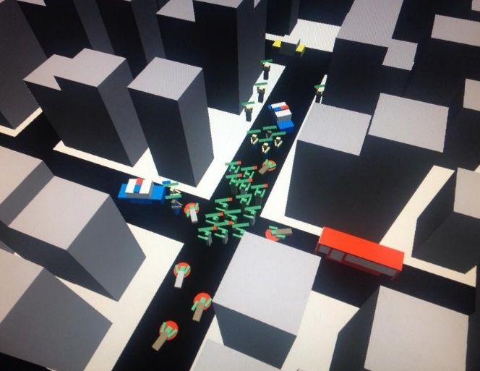Scale of buildings and objects will revolve around the size of the humans and zombies as we are aiming toward making players feel like they are looking down on a live city.

**1.8 Environment scale**

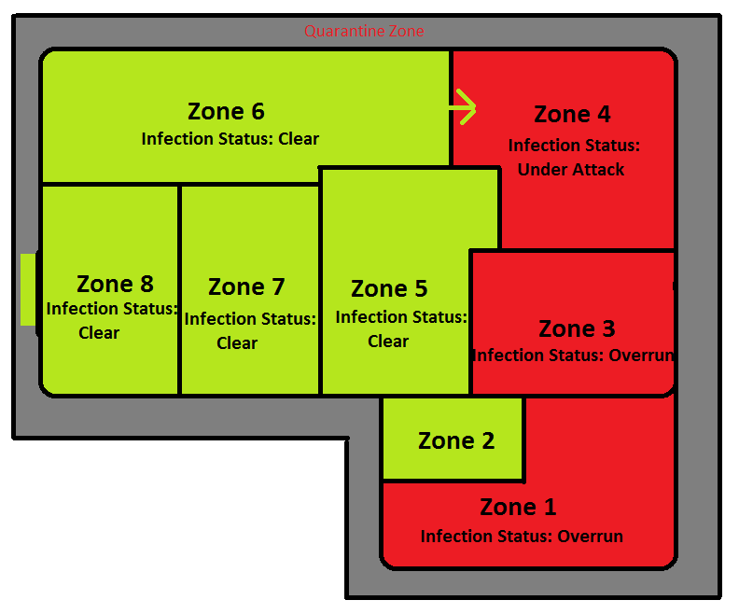The map is made up of a quarantine zone which is divided into individual territory’s, each territory being its own level which players fight to take control of. Each territory should be big enough for players to explore but not get lost.

**2.0 Character Art**

**2.1 Style and construction**

Simplistic, block characters. The simplicity of the characters allow for us to keep the polly count low which will allow for the games performance to run well on smartphones.

**2.2 Costume/drapery**



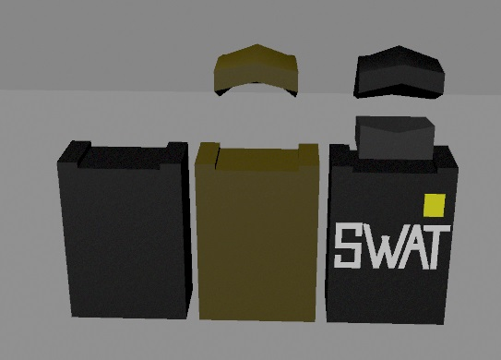

**Body Armor**

Adds additional HP to AI’s.

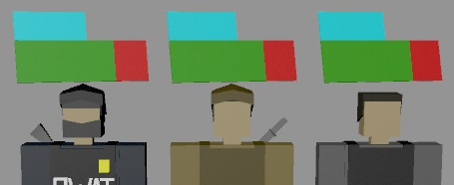

**2.3 Color palette**

**Human color palette: Zombie color palette:**



**2.4 Height scale comparison**

Human AI and weapon scales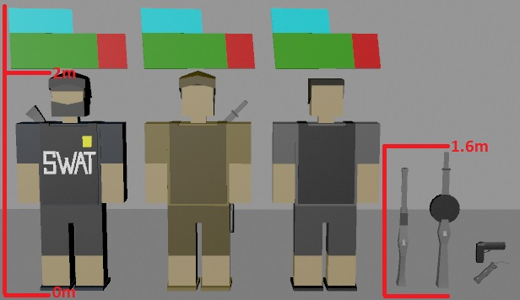

**2.5 Posing**

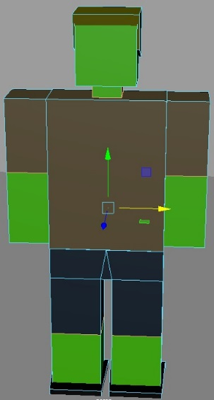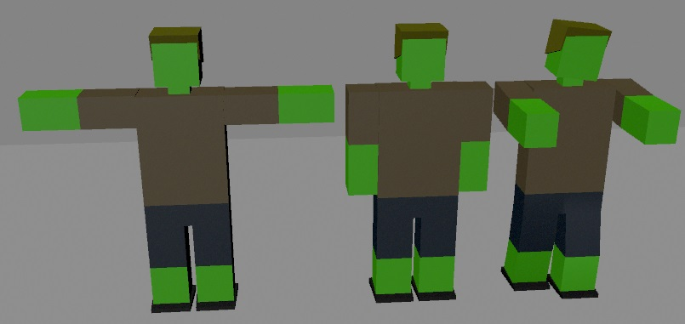

Models  
ready to  
be rigged

**2.6 Expressions**

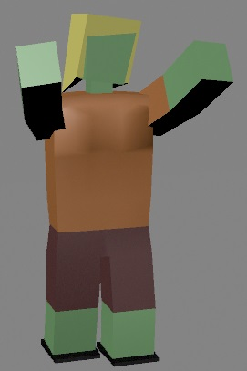Body language (Models do not require faces as the camera is too far to see them)

Over-exaggeration of body language

as a way of expressing their selves.

Zombie attacking:

Arms lunging out forward widely, head protruding forward and

legs running. Shows player zombie is attacking.

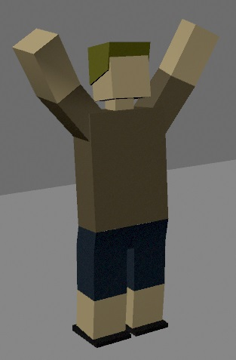

Human panicking:

Arms lunging up widely, head leaning back and legs jumping back.

Shows a human has been alerted.

**3.0 L.O.D. (Level Of Details)**

**3.1 Architectural details**

Architecture should represent that of modern day city such as New York or Adelaide. Buildings cannot be too high as the isometric camera will be above moving around so we want to avoid having to fade too many objects for the player to see through.

**3.2 Character details**

Characters should represent a block style version of modern day people. The models should retain a simplistic look whilst also looking very polished. Weapons and other items such as body armor also attach onto player models also adding certain buffs

**3.3 What and what not to detail**

The environment should be detailed enough to look aesthetically pleasing to the player’s eye, this is due to the environment having the biggest objects of the game. Objects including buildings which will be closest to the player camera.

As for assets such as characters since they will be quite small to the camera they won’t have to be as detailed but still detailed enough to look aesthetically pleasing from a distance.

**3.4 Differences of detail in narrative, gameplay and UI**

The narrative of the game is pretty simple, grow your horde to escape the quarantine zone. Narrative throughout Horde will mainly consist of immersive gameplay as users can create their own experience from exploring into random events such as safezones. As for the UI it will remain very simplistic as we wish to keep the player engaged so we aim for our UI to be diegetic.

**4.0 Camera**

**4.1 Gameplay angle and character position**

Hordes uses an isometric camera which follows the player’s horde from above, as buildings get in the way of the players vision they will fade allowing them to be see through.

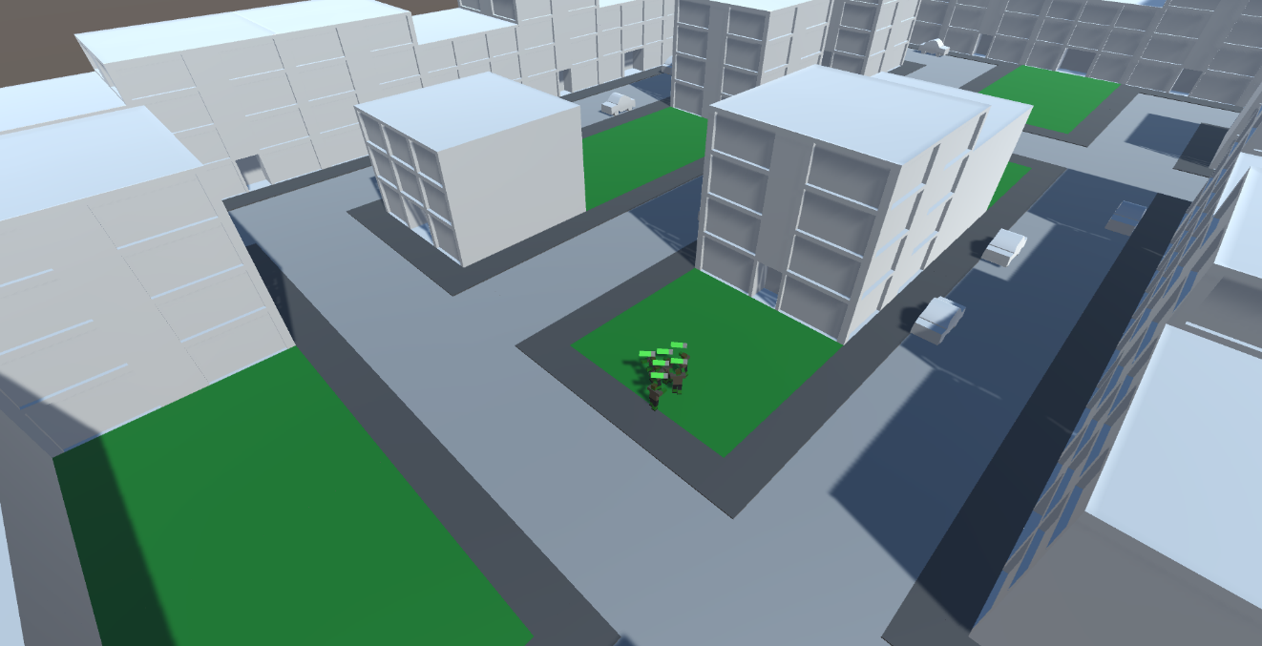

**4.2 Narrative/story sequences**

Horde will mainly revolve around the player exploring around the map freely, having random narrative events occur in certain locations. A random event currently being discussed is with the use of safe zones and possibly having AI from the safe zones fighting each other over disputes which allow the player to join in with their horde attacking them.

There will also be set story sequences that all players will experience, these being the intro tutorial story section and the ending quarantine wall gate.

**4.3 Camera FX**

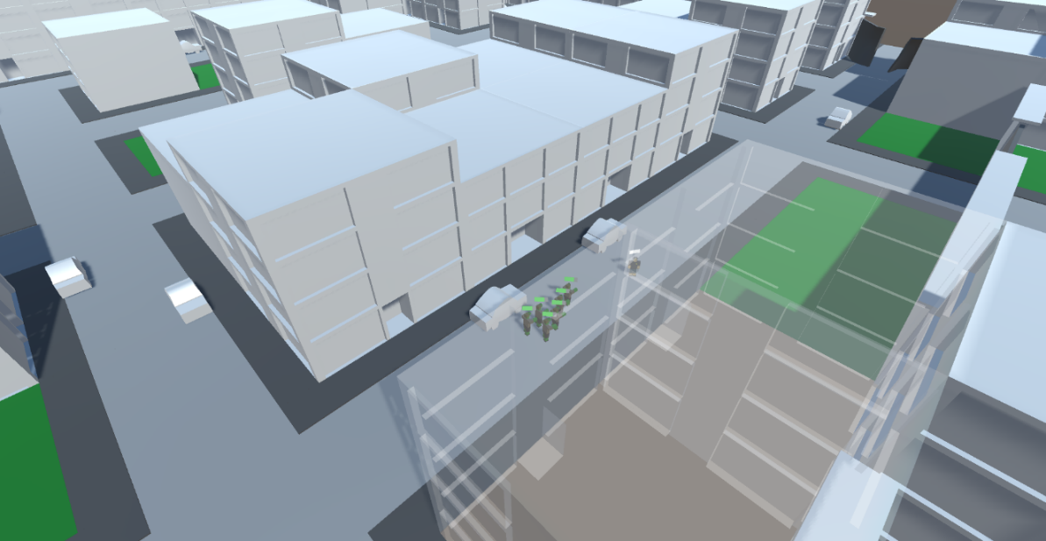A fade effect will be used on buildings that obstruct the players view to allow for players to always see their hordes position.

**5.0 Colour palette**

**5.1 Environments with distinctly different palette choices**

As Horde progresses levels will begin to become more and more post-apocalyptic, having buildings and other objects damaged and possibly on fire.

Earlier levels will have much brighter colors representing the area is peaceful until your horde desecrates the area, leaving it in a darker and ruined state.

**5.2 Color swatches**

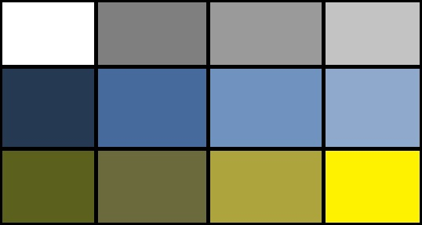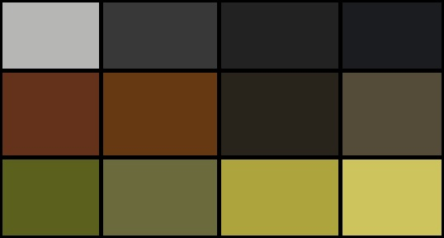Zombie color swatches Human color swatches

**6.0 Atmosphere/environment**

**6.1 Openness**

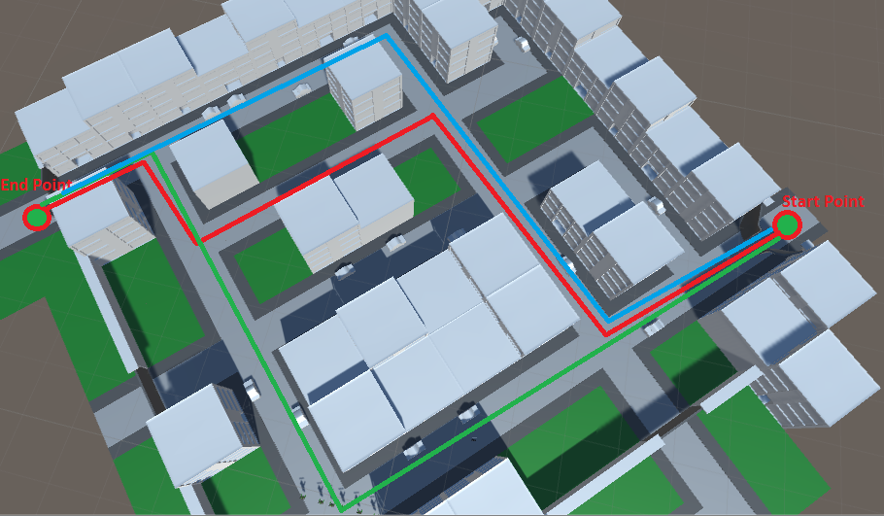Horde’s gameplay is set within a quarantine zone that is made up of explore able territories, these territories are each individual open world levels with various path ways the player can take

**6.2 Scale**

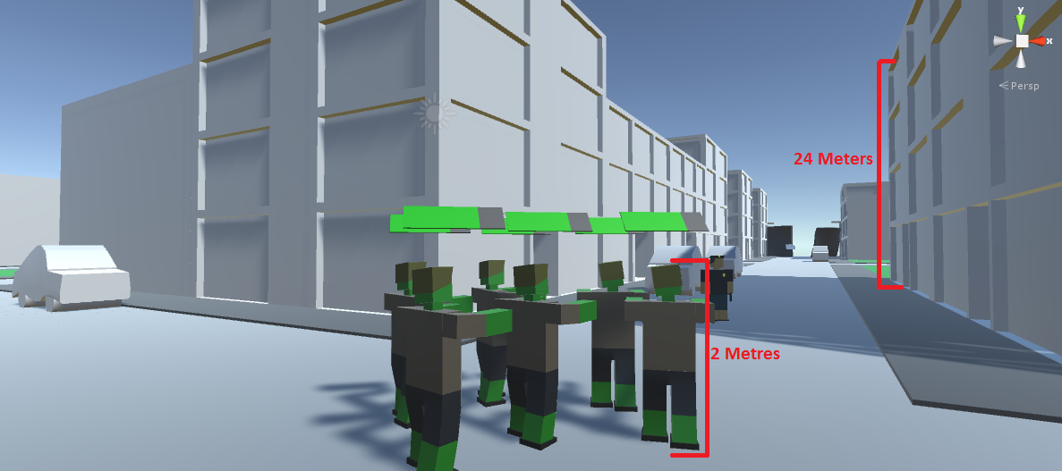Environment scale should represent that of a real life city, so therefore a floor on a building is roughly 6 meters tall so a 4 story building should be around 24 meters tall.

**7.0 User Interface**

**7.1 Interface design technique**

Horde aims to go for a minimalistic UI, leaving majority of the User Interface to be diegetic within the game. An example of our diegetic UI in the game can be for AI selection, rather than place a highlight around a selected zombie it will play sounds and animations to notify of the selection, e.g. moans and stretching out arms.

**7.2 UX (User Experience)**

Hordes UI will be kept simple and clean to allow for an easier and better user experience, players do not enjoy large amounts of text.

**7.3 Menu items and HUD**

Main Menu: (Map)

**Mutations:**Upgrade menu for zombies or abnormals

**Settings:**Allows players to change game settings



**Quit:**Quits the game



**Select Zone to Begin**

**Pause:**Freezes gameplays and drops down settings and map button

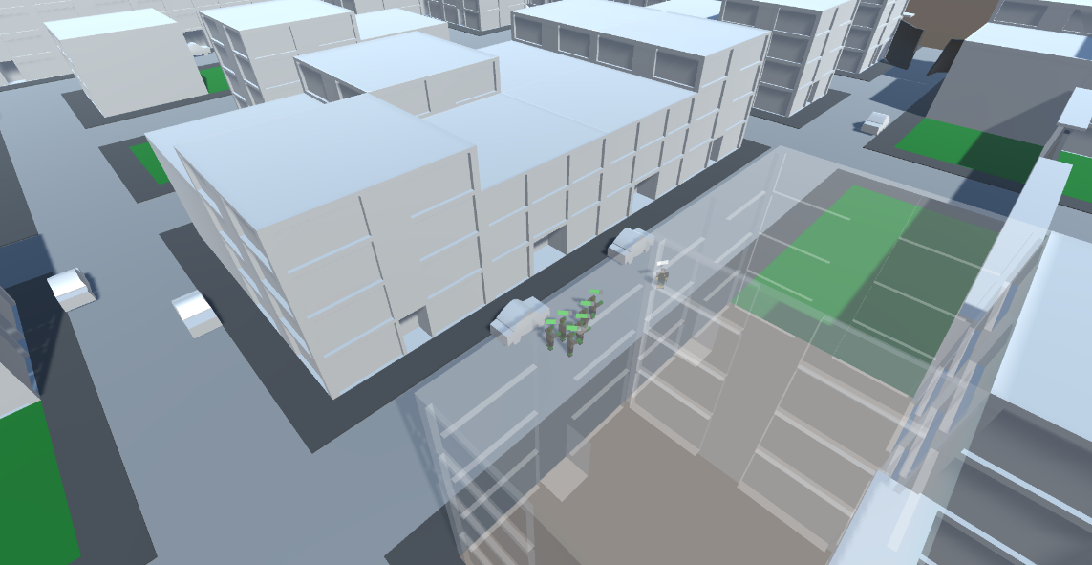Pause Menu:

**Settings:**Allows players to change game settings





**Map:**Takes player to the main map menu

**7.4 Animations**

Pause menu button, tapping this will play an animation of the settings and map icons dropping down from the pause button.

**8.0 Technical Guidelines**

**8.1 Tools to use**

Maya:   
Modelling and animating assets



Unity:   
Building the game

**8.2 Limitations**

As we are aiming for Horde to be on smartphones were are limiting are poly count by as much as possible, this is to ensure the game runs smoothly on most phones.

**8.3 Resource collection and structuring**

All resources are stored and worked on by team members using DropBox.

**8.4 Naming conventions**

All assets and files to do with the end product must be named clearly and efficiently as to allow other members of the production team to be able to find items easily.

**FBX’s:**  
Name_FBX_01

**Maya models:**  
Name_Model_01

**Textures:**  
Name_Texture_01

**Animations:**  
Name_Anim_01

**8.5 Exporting**

Models from Maya should be exported as FBX’s as Unity can easily import the file.

**9.0 References**

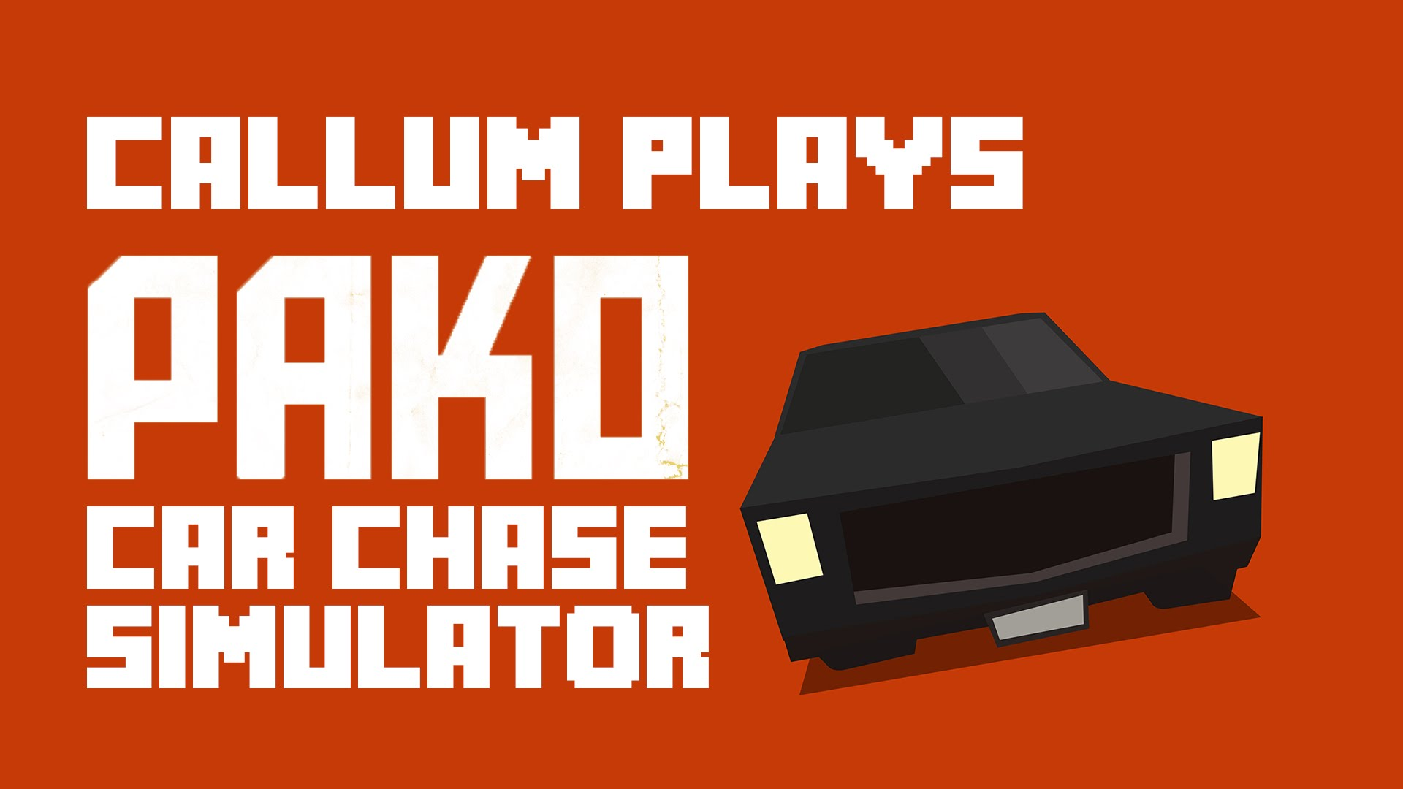**9.1 Games**

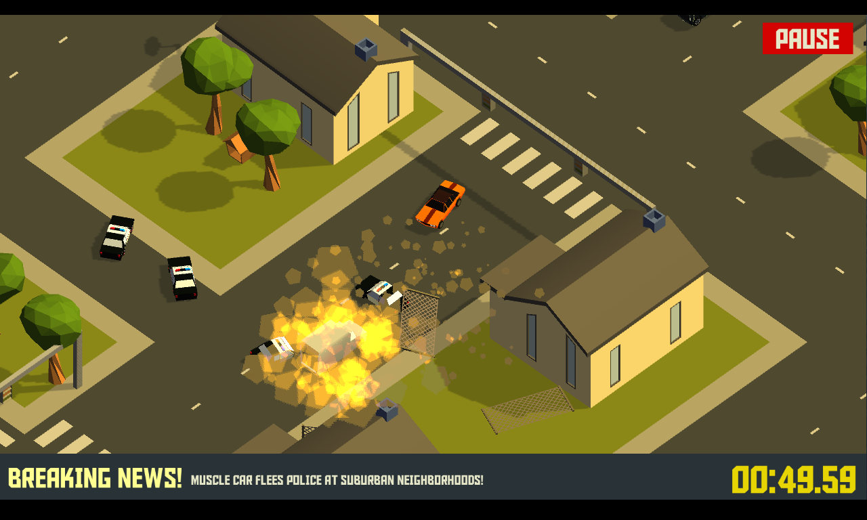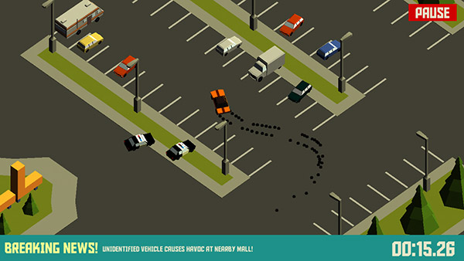

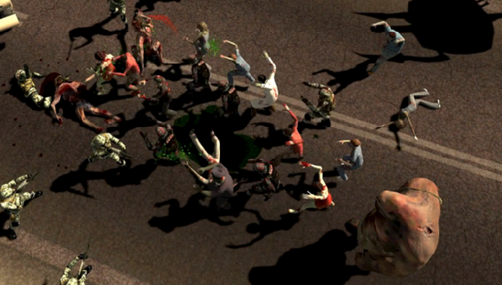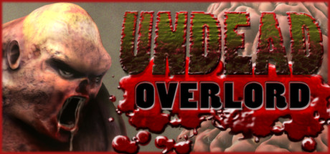

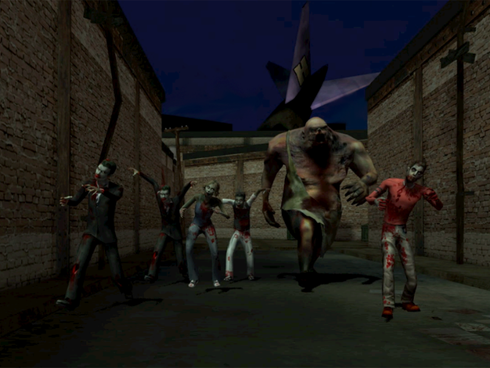

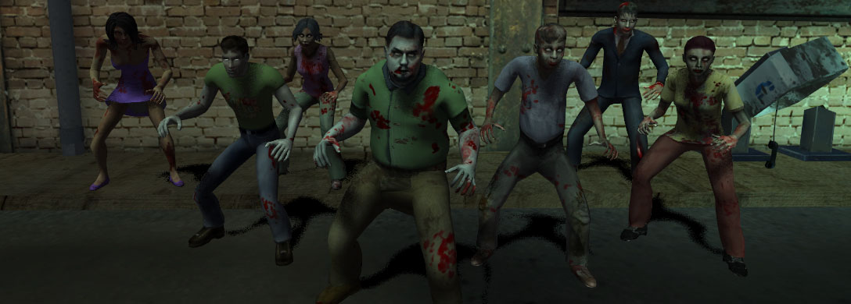

**9.2 Videos and movies**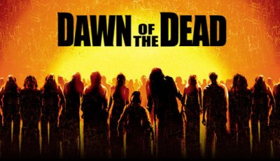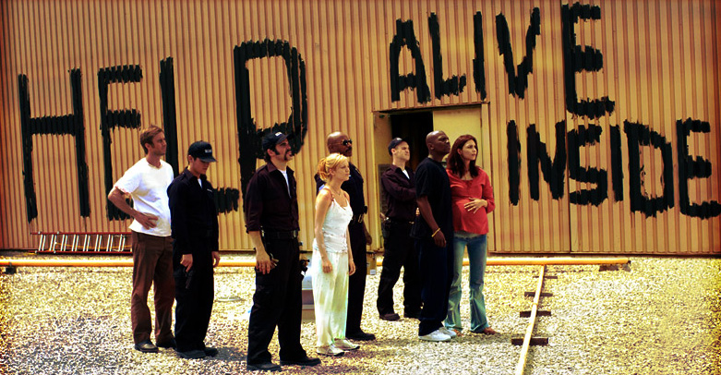

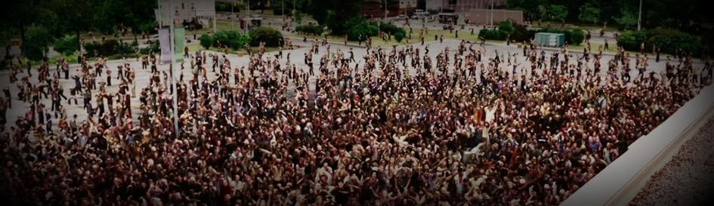

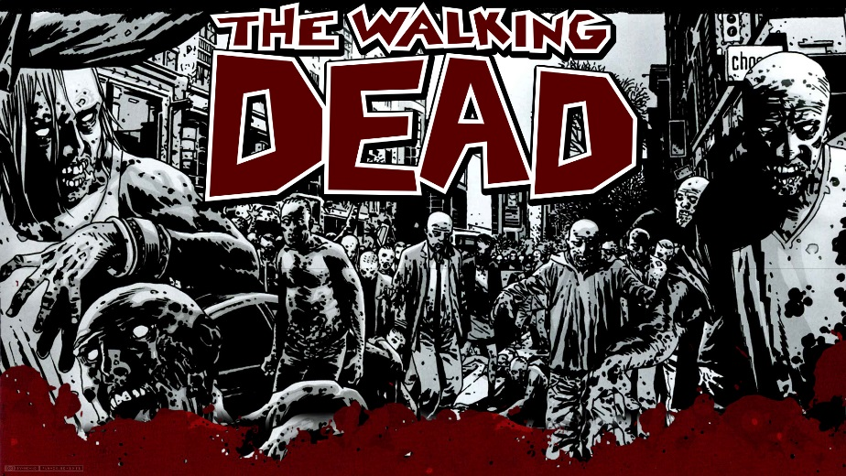**9.3 Comics**

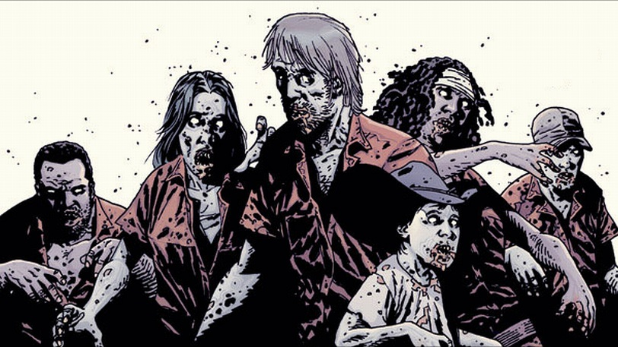

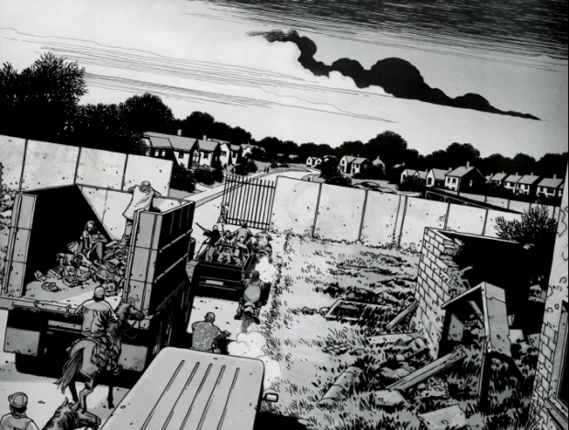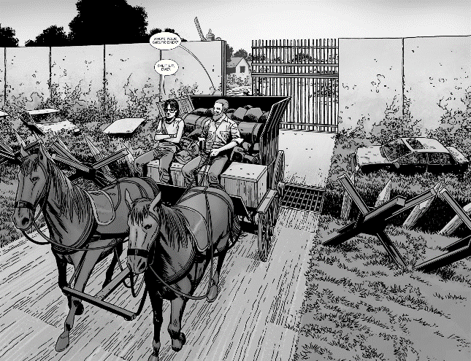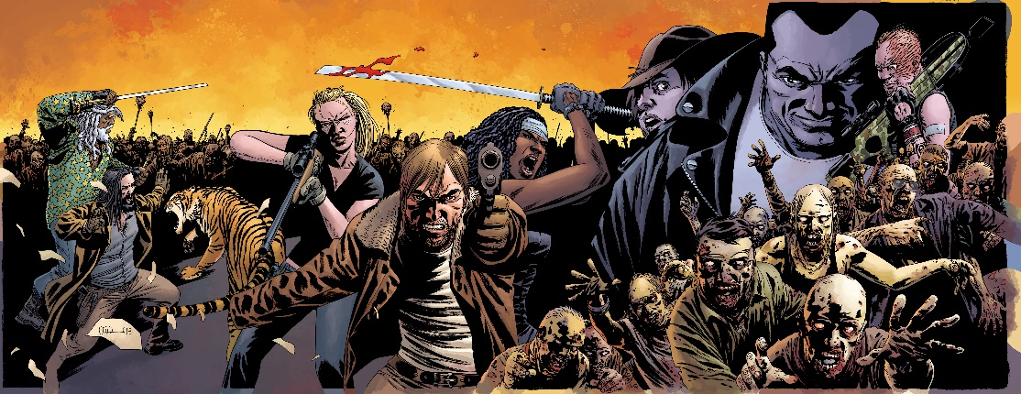

**9.4 Photographs**

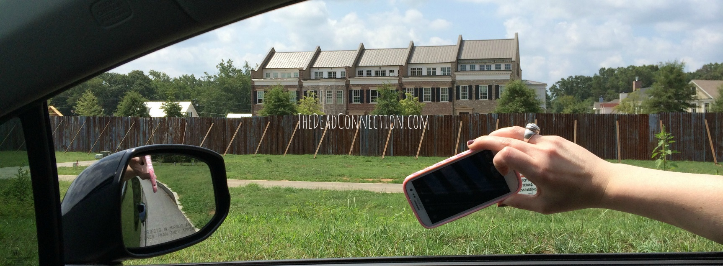The Walking Dead Alexandria Safe Zone set

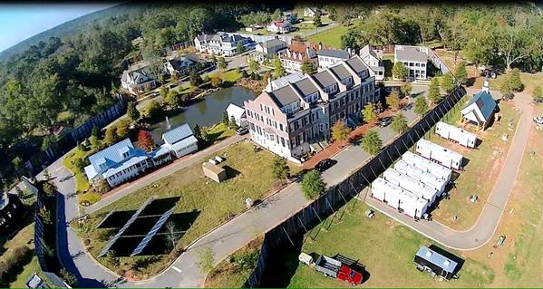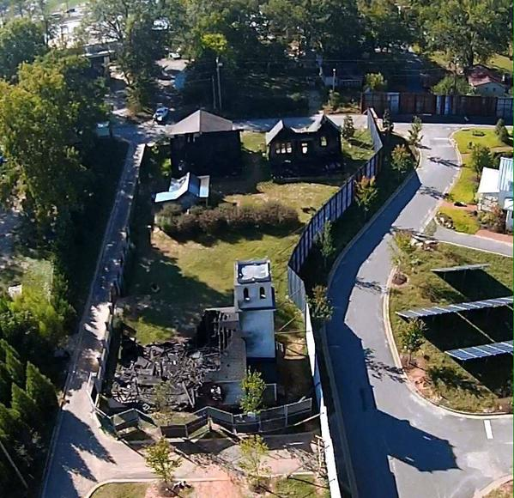

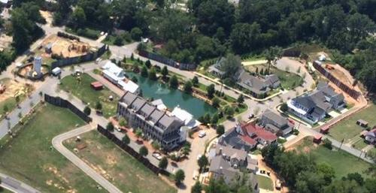

**9.5 Illustrations**

Left 4 Dead 2 concept art

